Guidelines for Eating Out

Eating out can be difficult when trying to limit calories. At Mac-Nutrition, we have a few tips that could help you cut calories when picking your meals!

- If having a 2 course meal, try to have a starter and a main rather than a main and a dessert as this will typically be lower in calories.

- Split your carbohydrates and fats e.g. do not choose a meal that is high in both carbohydrate and fat. Instead choose either a High-Carb, Low Fat (HCLF) meal or a Low-Carb, High Fat (LCHF) meal. Examples of each can be found below.

HIGH CARB, LOW FAT | LOW CARB, HIGH FAT
Roasted chicken risotto served with butternut squash and wild mushrooms | Grilled salmon served on a bed of wild rocket, avocado and red peppers drizzled with a lemon and herb dressing
Lean turkey breast served with sweet potato wedges and roast vegetables | 8oz premium Sirloin steak with melted garlic butter and mixed assorted vegetables
Smoked haddock fillet served with steamed rice and a side dish of glazed carrots and green leafy vegetables | Warm chorizo salad served with crumbled brazil nuts, mozzarella cheese, beetroot and spinach leaves
Lemon and garlic prawn stir fry served with steamed basmati rice | Ham & three cheese omelette served with dressed side salad
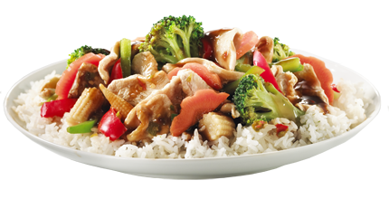 | 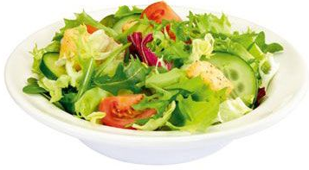  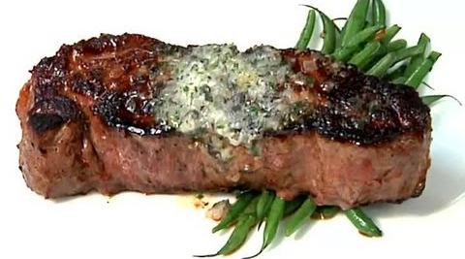

Dishes to try and avoid (typically high carbohydrate and high fat) include pizzas, chips, deep fried food, creamy pasta dishes (go tomato-based instead!), creamy Indian dishes if accompanied with rice/naan bread etc.

Additional Tips

- Ask for extra vegetables or salad instead of the carbohydrate option.

- Check the menu before leaving home so you know what to expect. If you can’t see a healthy option – choose a different restaurant!

- Skip the bread basket.

- Order a jug of water and continually sip throughout the meal to help with feelings of fullness.

- Eat normally throughout the day and keep protein intakes high so that you are not starving when you get to the restaurant as this will make it more likely to choose a bad option/overeat. It may also be worth eating a high-protein snack such as a whey protein shake before getting to the restaurant. Example below:

Breakfast | Lunch | Snack | MEAL OUT
Omelette with Vegetables | Chicken & Couscous Salad | Whey + Water | HCLF or LCHF Meal

- Alternatively, choose an intermittent fasting approach – fast throughout the day (do not have breakfast, or perhaps even breakfast and lunch) meaning you have a greater calorie allowance for your meal in the evening! Example below:

Breakfast | Lunch | Snack | MEAL OUT
Fast (Water only) |  |  | Meal of your choice

- Stick to low Calorie drinks e.g. water with sliced lemon, diet coke, diet lemonade, slimline tonic etc. Try not to drink alcohol as this will increase calorie intake and also reduces willpower! If you must drink, aim to drink spirits with diet mixers. These will be significantly lower in calories than wine or beer.

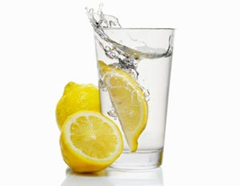
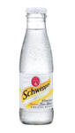

- Be savvy – options that are creamed, breaded, sautéed or fried are likely to be higher in calories. Stick to grilled, steamed or baked where possible.

- Beware of salad add-ons – croutons and mayo can send calories in a Caesar salad through the roof!

- Ask for dressings and sauces on the side – that way you can control how much you pour over your dish.

- Check your cut of meat. Breast has fewer Calories than thighs & rump has less than rib eye.

- Eat the amount you would eat at home – just because it’s in front of you, it doesn’t mean you have to eat it.

- Sorbet and frozen yoghurt are better options than chocolate fudge cake so if you need to satisfy a sweet tooth maybe choose one of these.

